# Chronozoom 3D Interactive - General

# A Foundation for Exploration and Gamification

[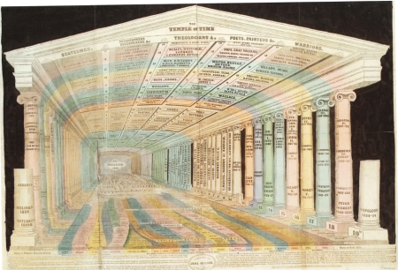](http://rapukemoana.files.wordpress.com/2011/08/thetempleoftime1.png)

Homage to Emma Willard – The Temple of Time, 1846

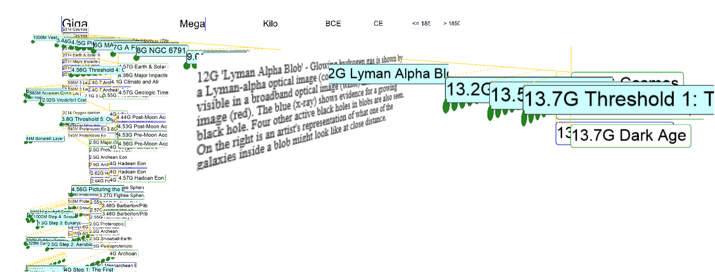

**Please view with IE 11 as other browsers have an unresolved issue.**

## Introduction

The primary motivation for this work is to increase the context of the data presented and the visceral feeling of the time-space, the “zoomability”. Chronozoom 3D will be used to create games that engage motor skills, using game controllers and Kinect to fly and jump. This action focus will make learning more effective in comparison to the passive nature of ChronoZoom beta.

A minimalist design approach has been followed to allow high information density and strong context with progressive revelation of detail through filtering and navigation. Event dates create implicit scales. By showing all elements in one view, context is continuous.

Artifacts are represented with their events as dots  , which are placeholders for the artifact images. They open on clicking. In the future, events and artifacts will expand as they are approached, as in ChronoZoom beta.

The initial display shows one “scale set” with one timeline and its events and artifacts. Dots are clickable, acting as placeholders for artifact images. They reveal the artifacts’ years, titles and descriptions (truncation of labels is a bug!). “Scale sets”, such as the Eight Thresholds of Big History, will be user configurable. sub-timelines are placed vertically in the order of recursive retrieval but many other arrangements are possible. The current vertical layout algorithm is primitive.

The Chronozoom tours would be represented by a series of lines linking events, as has been done for the causal links in the WW1 visualization (check WW1 and refresh).

To change the view, select the required checkboxes and **refresh the browser**.

## Technical

This interactive visualization is written in JavaScript using WebGL and the ThreeJS library.

Please view with IE 11 as other browsers have an unresolved issue.

Data is not cached so each refresh pulls down the data again.

### Issues

This work is early development and thus skeletal. The following are on the development schedule.

* Cross domain issues have so far prevented showing the artifact media.
* Truncation of timeline and event labels are an unresolved bug.
* The artifact dots with the events will be replaced by the media image thumbnail.
* Rapid zoom may cause zooming to stop. This is a performance bug.
* The sub-timeline order algorithm will be improved with more sorting and linking.
* “Scale sets” will be user configuration
* Navigation currently uses “trackball” controls will be improved to ‘flying” controls th
* Some events are disconnected from their timelines, which may be caused by a bug or data anomalies.